UML - Class diagrams

A static/structural model of a system that shows all the classes required to provide the functionality documented in the use case diagrams.
For each class it shows the attributes and the methods/operations. It also shows the associations between classes, class hierarchies (Inheritance) and aggregations/compositions of classes.
Account

Accno
Name
Balance

deposit()
withdraw()
getBalance()
showDetails()

Note Some designers include additional information such as attribute types, scope, method return types etc.
Account

-accno : integer
-name : string
-balance : float

+deposit(amt:float)
+withdraw(amt:float)
+float getBalance()
+showDetails()

Associations
An association is a relationship between two classes. It involves a property called cardinality/multiplicity which indicates the number of instances involved in the relationship. Based on cardinality, we can categorize relationships into 3 types: one-to-one, one-to-many and many-to-many.
- One-to-one
1 1
Dean
Faculty
- One-to-many
1 0..*
Order
Customer

- Many-to-many
0..* 1..*
Student
Course

Generalization (Inheritance)
Classes can be organized into a hierarchy when they have some common features. A new class can be derived from an existing class when the new class has an “Is-a-kind-of” of relationship with the old class.
Class diagrams can be used to show super classes and sub classes in a class hierarchy.

Product
#Productno : integer
#Description : string
#Price : float

+purchase()
+setPrice(price:float)
+showDetails()
HardDisk

-Capacity : integer
-Speed : string

+showDetails()
Monitor

-Size : integer

+integer getSize()
+showDetails()

Note: Super classes are normally declared ABSTRACT. An abstract class cannot be instantiated. In UML, abstract class names and abstract method names are written in italics.

Aggregations/Compositions of classes

This shows part-whole relationships between classes. A class can be a component/part of another class when there is an “Is-part-of” relationship.
e.g. Room is part of house, Garden is-part-of house

House

1

1
*
Room
Toilet

Window

1

*
1
Menu Bar
Tool Bar

SAMPLE CLASS DIAGRAM – Library System

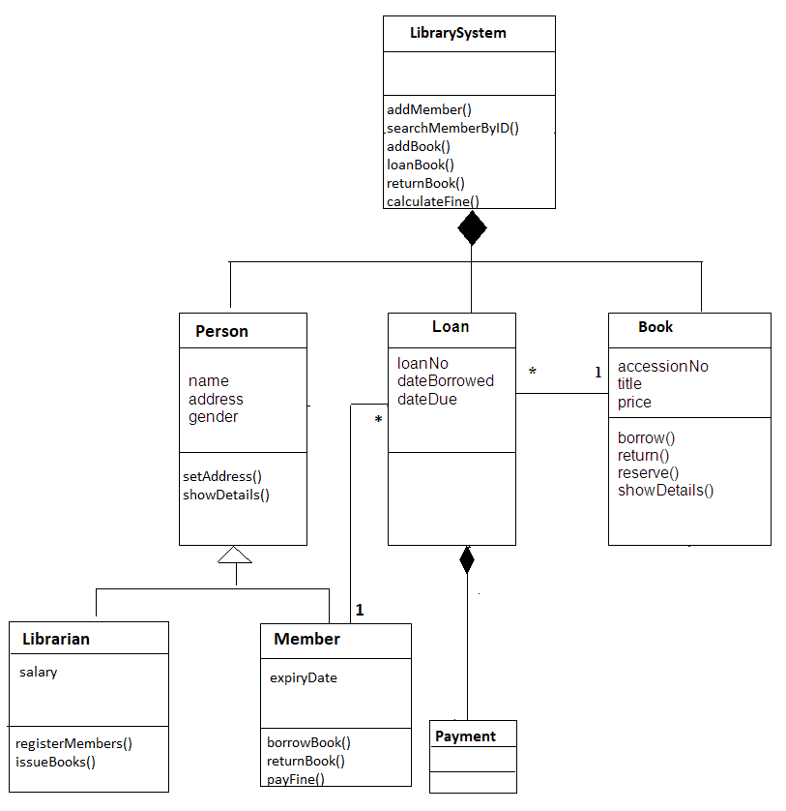

Key Design Decisions

The Abc Library system is developed using Object Oriented Programming style. In OOP, the system is made up of classes. Each class consists of attributes and methods. These classes have associations between them. They also have super classes and sub classes to allow inheritance of data and methods.
At run time, the objects made from these classes interact with each other by passing messages.
The class diagram serves as a blueprint for all the classes required in the system……………………

Member Class

The Member class represents a key entity in the library system. It represents the library members who borrow books. This entity stores vital information for each member. The attributes include member id, name, contact number, address and membership expiry date. The member id uniquely identifies each member. Each of these attributes have setters and getters to update and retrieve their values.

Book class
This is a key entity that stores data about books. Its attributes include accession number, title, author and publisher. …….

Loan class
This is a key entity that stores book loans………..

LibSys class
This serves as the main program that controls and coordinates all library functions. It defines the data structures that store data about members, books and loans of books. It presents a numbered menu for the user so that user can select an operation by number (example: number 1 for add member, 2 for display members and so on)…………..
Source Code

Testing

